SCHOOL ACCESS SECURITY PROCEDURES

For everyone’s safety, access of BIS Hanoi school premises is controlled at its gates.
We do this to ensure the safety of our students and staff on campus as well as the protection of school property. Guards will only allow a person to enter the school grounds with a valid reason.

The guards are instructed to follow procedures and do so with the full support of the school. If you are unhappy about the management of a situation, we ask you to act respectfully in the presence of children and bring any issues up directly with a member of the Senior Leadership Team.

BIS Hanoi Access ID Cards and Lanyards

There are five different types of ID cards and lanyards:

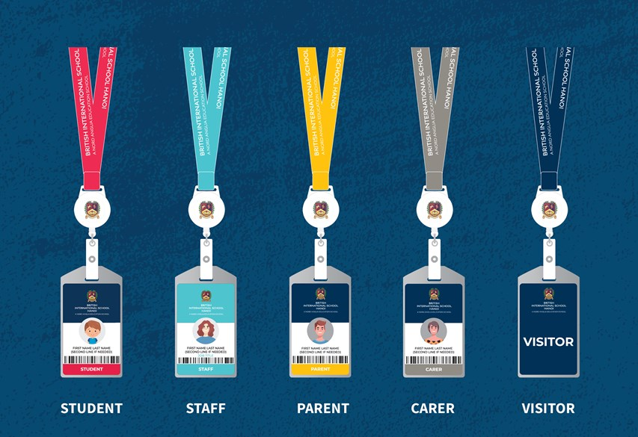

Only staff, students, (registered) parents, (registered) drivers/nannies will have permanent photo ID swipe cards.
** ALL ADULTS will be expected to wear a lanyard at all times unless there are practical reasons for not.
- The exception for this will be those departments in uniform e.g., PE, Maintenance, Security Guards, Cleaners.
- Students in school uniform are also exempt.

How to use the BIS Hanoi Access Card

Please see the image below for instructions on how to use a BIS Hanoi access card:
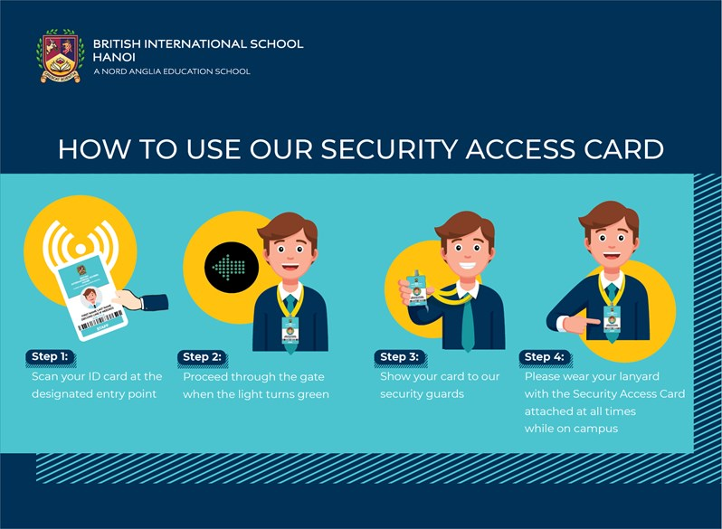

Students Using the BIS Hanoi Bus Service

In the morning
- As they get on the bus, they are required to tap their new ID card on the bus touchpad.
- As they get off the bus, they need to swipe their ID card on the Main Entrance touchpad before entering the school building.

At the end of the day
- Before leaving the school building, they need to swipe their ID card on the Main Entrance touchpad.
- As they get on the bus, they are required to tap their ID card on the bus touchpad and do it again as they get off the bus.

This information supports the tracking of students both on and off-campus and along their bus routes.

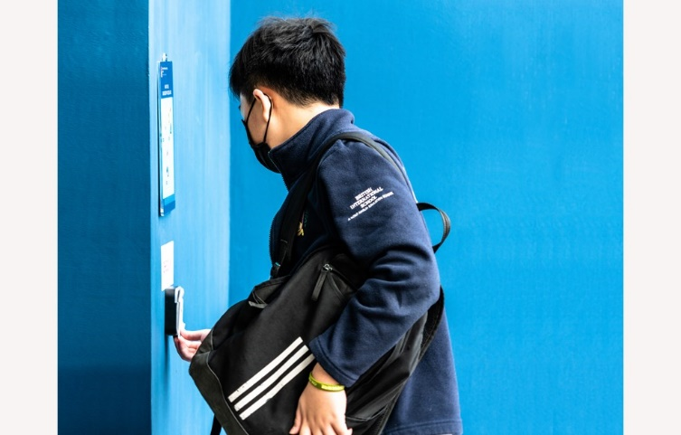

Security Procedures

Campus Maps

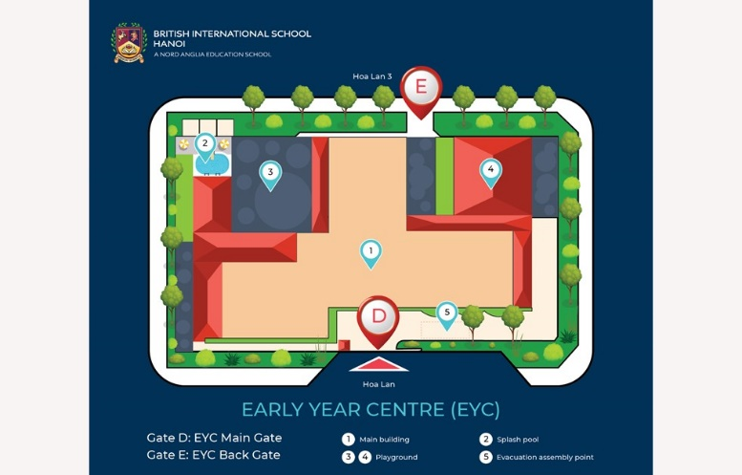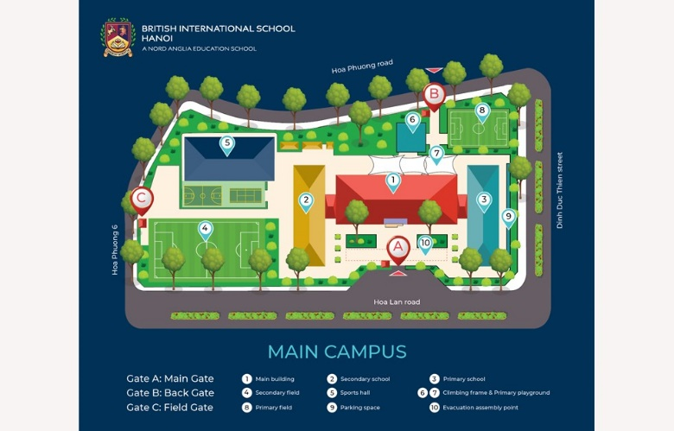

Security Procedures for Students, Parents & Carers

Beginning of the day:
- All students to enter through their respective gates (Gates B (Back Gate) and D (EYC Main Gate) and Main Campus Entrance touch pads).
- Upon late arrival, only Gate A (Main Gate) and D (EYC Main Gate) will be used.
- No student entrance to either campus will be allowed before 8:10am daily (early clubs/training, by prior arrangement with staff only).

End of the day:
- All students to exit through Gate A, B and D from 15:00 until 16:30. After 16:30 only Gate A and D will be used.
- No entrance for anyone after 17:00. If there is a school-authorised evening event taking place, the gates should be closed for the evening within 30 minutes of the event finish.
- Site closed from 21:00 - 06:00.

Security Procedures for Visitors

All Visitors on arrival (including parents, teachers, drivers and nannies without swipe card):

- Stop for Visitor Pass (blue lanyard) at the gate.
- Complete the digital form on security screen.
- Print visitor label, attach to the Visitor Pass. To be worn at all times.
- Visitors directed to the Reception desk at either Main Entrance or EYC Entrance.
- Visitor Pass must be handed back to Security on exit.

