BIS HANOI ID CARD AND LANYARD ALLOCATION

For everyone’s safety, the issuing of BIS Hanoi access cards is limited as below:

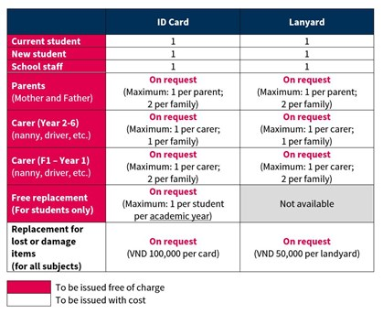

Issuing of Cards at No Charge

Staff
- All staff will be automatically issued with maximum (1) card + (1) lanyard

Students
- All current students in 2022 during new roll out only receive maximum (1) card + (1) lanyard per person.
- All new students will receive maximum (1) card + (1) lanyard per person.
- All students will receive maximum (1) new card per person per academic year by request only

Parents & Carers (by request only)
- All parents (Mother + Father) can request maximum (1) card + (1) lanyard per person (maximum (2) Parent ID cards per family, no matter number of children in school)
- For families with at least one student in Year 2 – 6, parents can request (1) card + (1) lanyard for (1) Carer (e.g., nanny/or driver) (maximum (1) Carer ID cards per family, no matter number of children in school)
- For families with at least one student in F1 – Year 1, parents can request (1) card + (1) lanyard each for up to (2) Carers (e.g., nanny and/or driver) (maximum (2) Carer ID cards per family, no matter number of children in school)

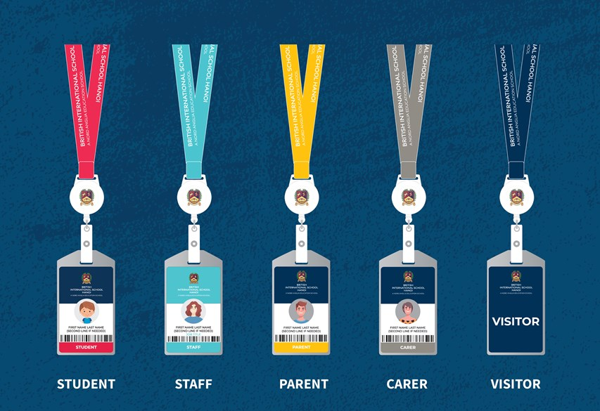

Replacing an ID card (charged)

All Lost or Damaged ID Cards and Lanyards will be charged for:
- Replacement cost of new ID card: 100,000 VND
- Replacement cost of new lanyard: 50,000 VND

Requesting a new ID Card and/or Lanyard

Any new cards for Parents will only be issued when the ID Card Registration Form is completed by the parent using their child’s school account. These can be picked up when produced from the Main Campus Reception desk (3-day turnaround time).

Any new cards for Carers will only be issued when the ID Card Registration Form is completed by the parent using their child’s school account. These can be picked up by the parent when produced from the Main Campus Reception desk (3-day turnaround time).
Requesting for the replacement of an ID card and/or Lanyard

Any replacement cards for Parents will only be issued when the Request for a Replacement ID card Form is completed by the parent using their child’s school account. These can be picked up when produced from the Main Campus Reception desk (3 day turnaround time).

Any replacement cards for Carers will only be issued when the Request for a Replacement ID card Form is completed by the parent using their child’s school account. These can be picked up by the parent when produced from the Main Campus Reception desk (3 day turnaround time).

Students requiring a replacement card should fill in this form HERE and collect their card at the Main Campus Reception desk (1 day turnaround time).

Parents/Students/Staff requiring a new lanyard can purchase from the Main Campus Reception desk.

